**Input Data**:

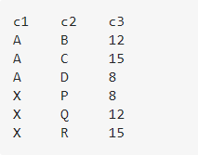

**Transformation Logic**: I want to select those rows of top contributing (top 50 percent contributor for sum of c3 values, ex: 12 and 15 has contribution more than 50 percent of 12,15 and 8) c2 values for each c1 values.

**Output**:

